Abstract
The character of Ariel in Shakespeare’s The Tempest takes many forms over the play, making numerous physical transformations in order to make mischief. In the long production history of the play, the character has been played by actors of all genders, but how is the fluidity of the character represented in the pronouns used in academic writing over the years?

Introduction
In The Tempest the character of Ariel is listed in the dramatis personae as an “airy spirit”. The male pronoun he is used in reference to the character once, but they are far more frequently referred to as “spirit” or by a variety of nicknames including “my bird,” “delicate Ariel”, and often fondly as “my Ariel.” Over the course of the play Ariel takes the form of a sea-nymph, a harpy, and most likely the goddess Ceres. The role has been played by actors of all genders over the years; it originated as a young boy’s part, was largely portrayed by women in the romantic period, and is now played by all genders and sometimes by more than one actor of various genders. There is a strong textual argument to be made that Ariel is not male, or female, or necessarily any gender, but just genderless spirit.

Given the ambiguous text, and the varied production history, I was interested to see how Ariel had been gendered in academic books and articles over time. Tracking pronoun usage for this character in scholarly writing could potentially be a snapshot for how understanding of the text, and of gender, has changed over the years.

Base dataset
The data set was collected from a collection of articles and book chapters found through CUNY OneSearch. Other collections were considered - including JSTOR or MLA. Ultimately, the decision was made to use CUNY OneSearch because it offered the greatest ease of use and access. OneSearch allows the user to filter searches by which texts are fully available through The Graduate Center, where I am a student. Because this project necessitates having access to full texts, this streamlined the data collection process considerably. Given the short time available to complete the project, and the positioning of the project as a teaching-tool rather than a published piece of academic research, this felt like the right position.

However, this choice did limit the data set in several ways. First, CUNY OneSearch is searching metadata and titles, not full texts. This is helpful if you are looking for the most relevant works to your research topic, but for a project using a zoomed-out approach like this one it means that you are potentially missing articles that could have contributed to your dataset. Having less articles makes the project more manageable and less time consuming, but it may also be less accurate. Using CUNY OneSearch is also limiting, and biased, because you are only seeing articles that the Graduate Center has full digital access to. Choosing to limit your project to these sources means that your research is already biased by the access decisions made by the university: decisions which may be financial, political, or quality based. A more thorough approach would be to use JSTOR or MLA, and then use Interlibrary Loans to gain access to articles and books not directly available through the Graduate Center. This method would also include works that had not been digitized. It is, however, a vastly more time consuming approach.

My search terms in OneSearch were “The Tempest” + Shakespeare + Ariel. I applied filters limiting the search to articles, books, book chapters, and dissertations where the full text was available online (this also removed results for audio and visual documents). The resulting data set was 104 documents. 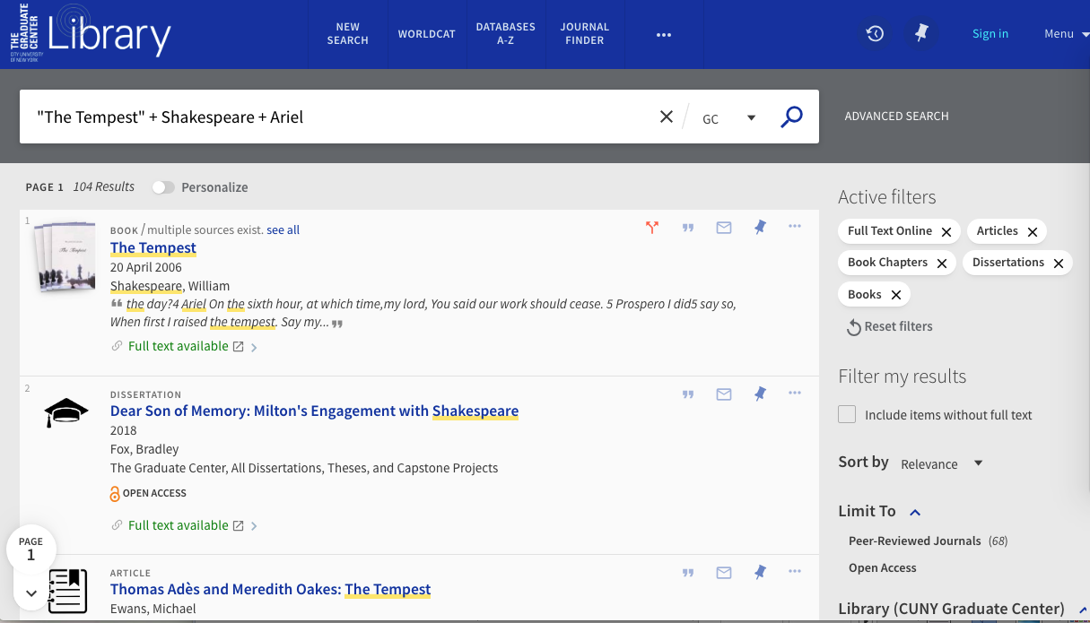

My next step was to download all the articles as PDFs. I had to do this manually, going through the search results and grabbing them one by one. This process was slow and laborious, but it had the benefit of acting as a second round filter. In this stage of the process I caught many articles that were unsuitable for this project (for instance, articles about productions or other interpretations of The Tempest that didn’t discuss the original text), and also a significant number of duplicate entries. I should also note here that I did not catch every unsuitable article during this step in the process, and continued to refine the data set into the next steps. I ended up with a data set that was culled from 104 results to 39 pdf files.
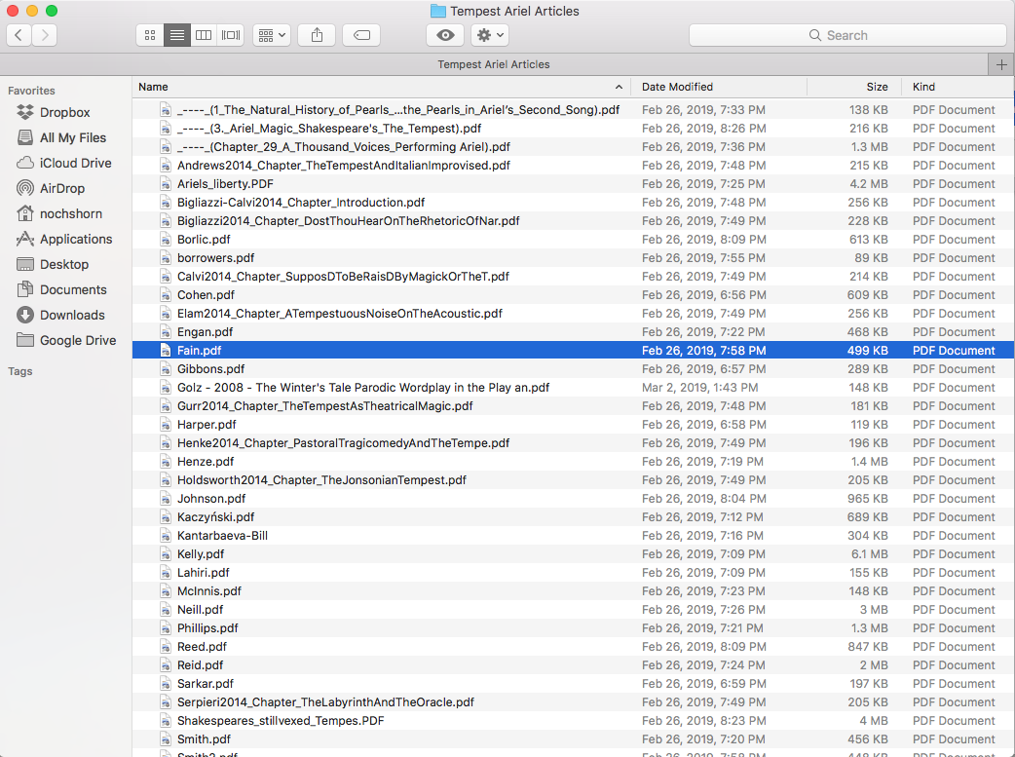

Transform stage 1

I created a simple spreadsheet using Google Docs to compile the information I was pulling out of the articles. This included the article name, author(s) name(s), year of publication, and the pronouns (if any) ascribed to the character Ariel. My method for finding this information was simple, but time and labor intensive. I opened each article, searched the text for the name Ariel, and read as many of the surrounding sentences were still discussing the character to see if there was a pronoun used. If the PDF was not searchable I would skim the entire article. There are likely programming methods that would have made this process go faster and easier, but there were some advantages to my method. The first is that it served my programming skill level, and demonstrates that having an advanced technical education is not always necessary for doing digital projects. The second is that it allowed this step to act as another point in which the documents were being checked for relevance. The third is that manually reading through the articles gave me a sense of the context in which Ariel was being discussed; something that eventually influenced the direction of the project.

The results of this stage were initially disappointing. Of the thirty-nine articles, book chapters, and dissertations, only two used gender neutral pronouns for the character. Ten never used a pronoun for Ariel. The other twenty-seven all used the male pronouns he/his.
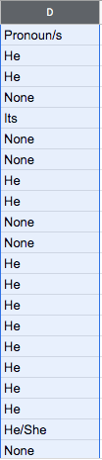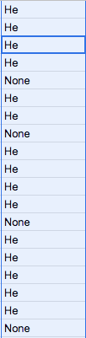

I will admit that I had hoped for some kind of trend towards gender-neutral pronouns as time went on. As far as this data showed, the two instances of neutral pronoun use were in 2007 and 2014; both fairly recent but too isolated and scattered to predict any kind of trend.

Transform stage 2
What I did notice while I was looking for pronoun use was that some articles would specifically discuss Ariel’s gender-ambiguity in the text or performance history, and then still use male pronouns. This raised interesting questions about how likely the habits or conventions of scholarship are likely to change even as our ideas about constructions like gender are in constant states of flux. I went back into the articles, and added a new column to my spreadsheet documenting whether Ariel’s gender or gender presentation was discussed in anyway. I debated whether or not to present this information as a binary (Discussion/No Discussion), but I ultimately decided to give a brief descriptive note or quote when there was some discussion of gender, because I wanted to depict the many forms that discussion took. 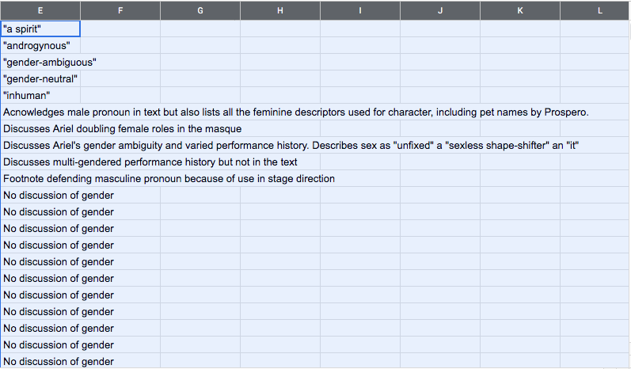

Prepped for analysis
I decided to make a series of simple charts to visualize the data in order to make what I found interesting about it more easily recognizable. First, a chart showing the number of articles I was able to gather for every year.
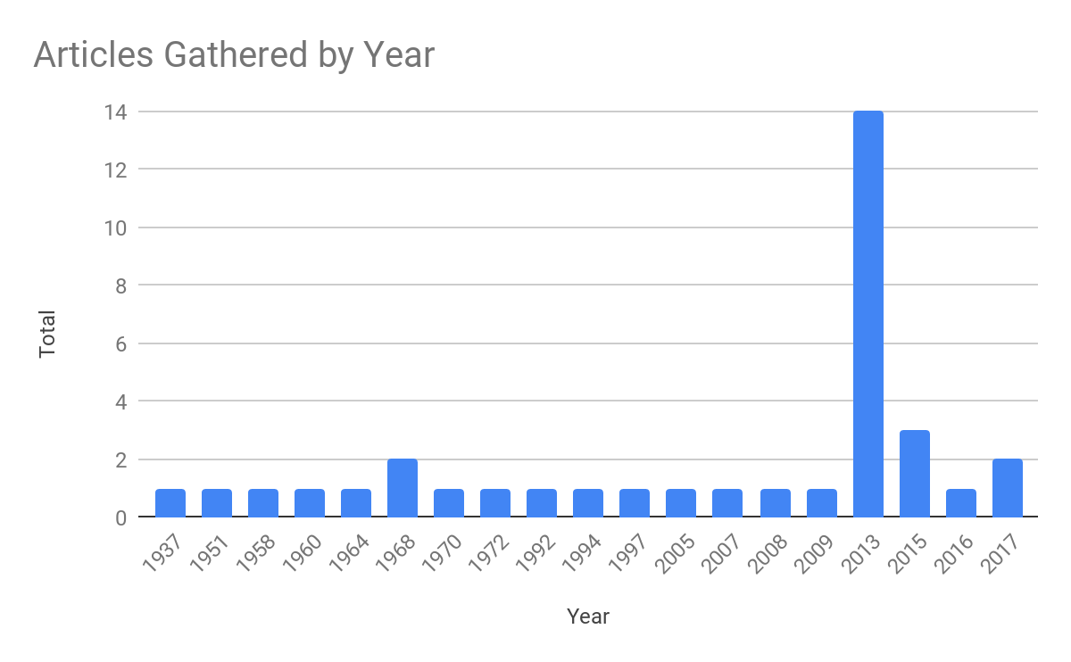
A chart showing pronoun use over time.

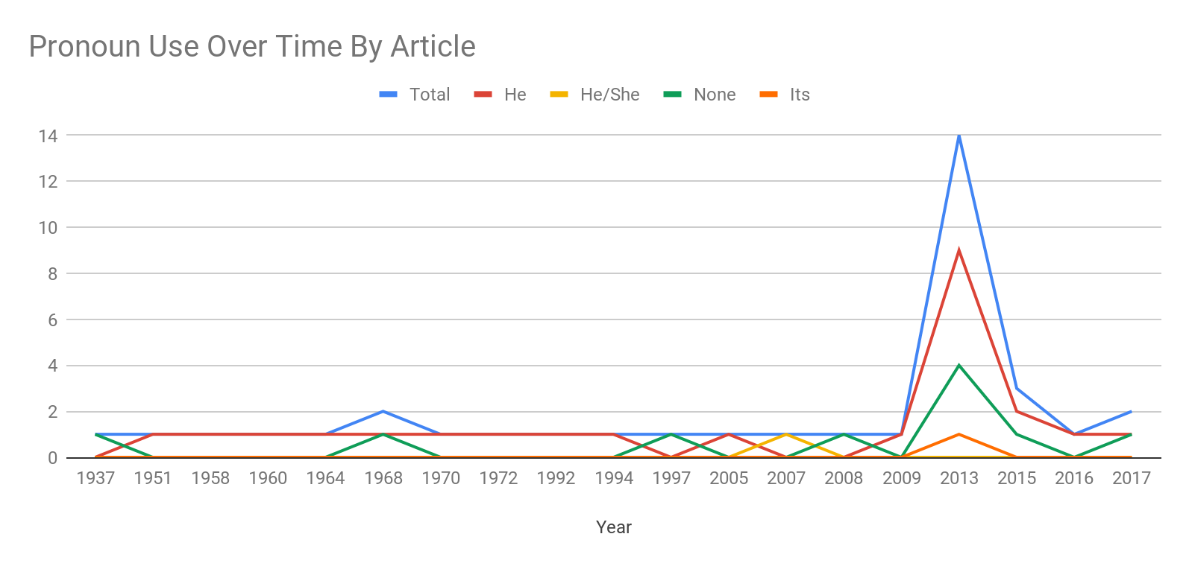

Analysis

